ML Algorithms
- Simple Linear Regression:
It is a method used to model the relationship between one input variable (X) and one output variable (Y) using a straight line.

Fit the best straight line through data points to predict Y from X

- Line Equation mathematically:
y=mx+c
- Slope(m):
Shows how much y changes when x increases by 1
Example:
𝑚=2
m=2 → when x increases by 1, y increases by 2
- Intercept(b/c):
Value of y when x = 0
Where the line cuts the y-axis
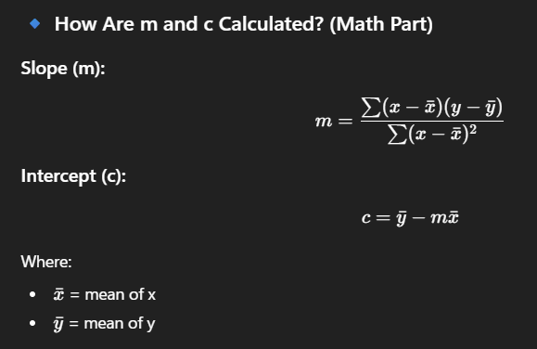
- The Algorithm actually calculates the m and b values
- We want that the error or the distance from each point to line should be less so wee need to find the values of m and b in such way that this
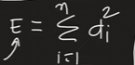
Function has less value.

- Error is di = yi – ŷi where:
yi = actual value of the output
ŷi = predicted value from the regression model
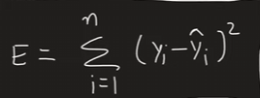

- But as we know ŷi = m*xi + b where xi = is input
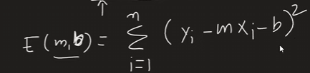

- Finding b:

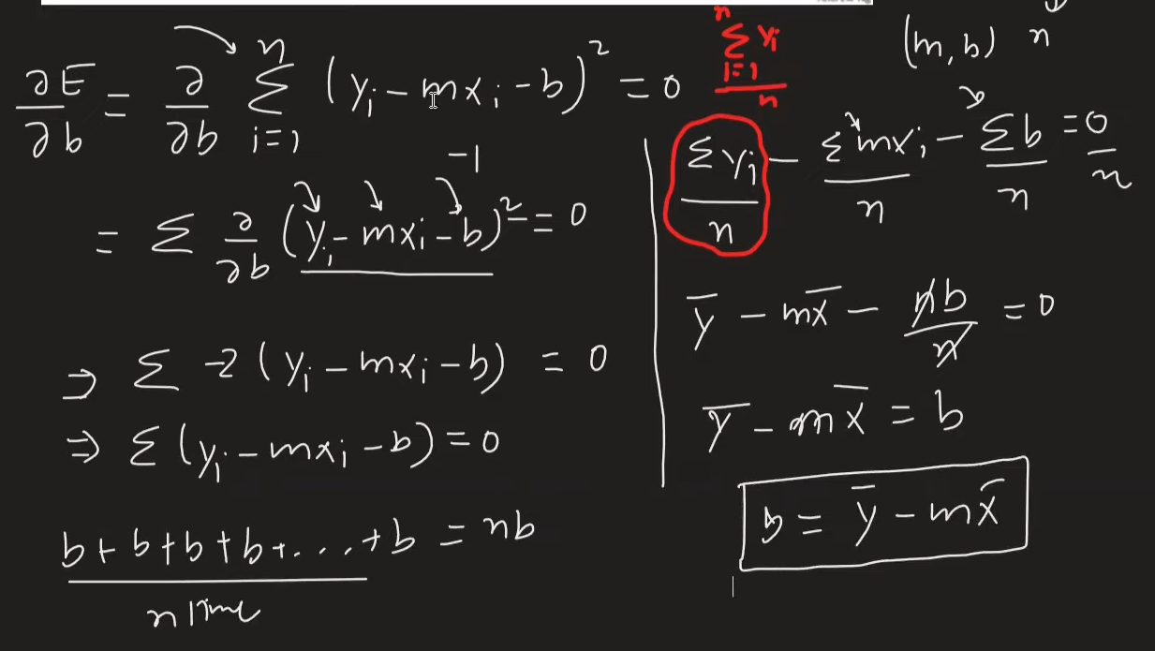

- Finding m:

